**GAME DESIGN DOCUMENT**

**Yarl: yet another roguelike**

**Ivan Khokhlachev (fitech student)**

Contents

Executive Summary, Quick overview 3

Target Audience 3

Main Characters 3

Main Features 3

World generation 3

Game actors 4

Actor progression 4

Level progression 5

Enemies 5

Knight combat 6

Pickups 6

Ending the game 7

Controls 7

Ui 7

Business definitions 8

Outsourced assets 8

# Executive Summary, Quick overview

Yarl is a simple coffebreak roguelike built around endless progression. Originally game was designed to be turn-based, but after some thinking was changed to be real time.

Objective of the player is to navigate through randomly generated level, kill enemies and find the key in order to progress to the next level. Once character dies – player will be able to add his name to the high score list.

# Target Audience

Game is designed to played as simple timekiller, as such it is intended for anyone who has time to spare and kill. No mature themes or horrible difficulty spikes are planned

# Main Characters

Figure 1, Knight, main character

Game has a single main game character, who can be named as Knight. Knight is a simple person, and all he knows is killing enemies and progressing levels until death.

# Main Features

### World generation

World is being generated randomly out of predefined rooms. Every new level will have rooms in a different order. Every level will have a guaranteed ladder tile, that works as a gate to the next level.

All enemies are set after new level is generated. Game will take enemies out of predefined pool and set them in random order. One of the enemies will be guaranteed to have a key for level transition.

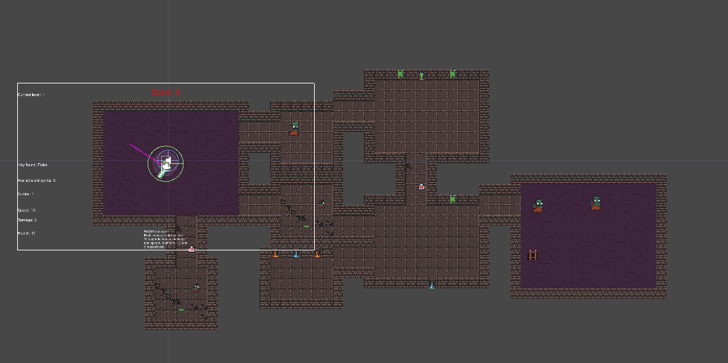

Figure 2, Randomly generated dungeon

### Game actors

Each game actor (including Knight) has a set of three characteristics: health (HP), damage (DMG) and speed (SPD).

Health represents pool of hit points which will drain after actor receives a damage. Game has no damage thresholds, so amount of drained hit points equals the damage score of an attacker (except for bomb attacks, which will be explained later).

Speed represents characters moving speed. In case of Knight - speed affects an attack cooldown. At level 20 speed Knight will have no attack cooldown. Formulae for Knight’s attack cooldown is: 2 seconds – (speed * 10%).

After receiving a damage every actor will enter the immunity window phase that will be accompanied by flashing, and actor will not be able to receive any damage until immunity window ends.

Each enemy has a score value that will be added to total score of a player once killed.

### Actor progression

For each completed level Knight will get a single skillpoint, which can be put into speed, health or damage.

¨

Each five levels enemies will gain one additional HP and DMG.

### Level progression

Figure 3, key that is needed to progress

At each level one enemy will be guaranteed to have a key that player has to obtain in order to traverse to the next level. After obtaining the key player has to find a ladder that will lead to the next level. (Figures 3 and 4)

### Enemies

Game has 3 enemy types: Ogre, Goblin and Bomber Orc. (Figure 5)

#### Ogre

Score value 300.

Ogre is a strong but slow enemy, has medium health pool, small speed and biggest damage in game

#### Goblin

Figure 4, a ladder to the next level

Score value 100.

Goblin is a small enemy type. Goblin has high speed, but small damage and health pool.

#### Bomber orc

Score value 200.

Bomber orc has biggest health pool and medium damage. Once Bomber orc sees Knight, it will try to get closer and start charging the bomb. After bomb is charged it will explode and damage everyone within explosion collider, including himself. Damage to player equals the base damage of Bomber orc, and to all friendlies damage is divided by 2.

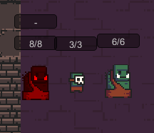

Figure 5, Enemies: Bomber, Goblin, Ogre

### Knight combat

Knight has two attack moves: normal attack and a bomb. Normal attack will give a damage to enemy equaling the base damage value of Knight. After each attack Knight will gain a cooldown that depends on Knight’s current speed value.

Bomb is an active skill that drains bombs that Knight holds. Knight can hold an unlimited number of bombs, however at start he has only one bomb. Bomb will harm all enemies (will not harm Knight) within the damage collider. Damage to all enemies equals base Knight’s damage divided by two.

### Pickups

Game has 4 pickups. Pickups are divided into two types: temporary (will be exhausted after some time) and permanent. Additionally, some enemies will drop upon death any of following four pickups. (Figure 6)

#### Permanent pickups

* Hp potion
  + Will give player 3 health or less if HP pool is almost full
* Bomb
  + Will add one bomb to players bomb number

#### Temporary pickups

Temporary pickups can stack. Potentially player can pickup unlimited amount of potions.

* Speed potion
  + Will raise players speed by 2 for 5 seconds
* Damage potion
  + Will raise players damage by 2 for 20 seconds

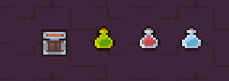

Figure 6, Pickups: bomb, damage, health and speed

# Ending the game

Game will end only once Knight is dead or quits the game. After dying player will be able to save his name to the scoreboard. Scoreboard is ordered by the level and score.

# Controls

Game is controlled by mouse and keyboard.

* To move use WASD
* To attack use Right mouse button
* To use bomb use Q
* To level up characteristic use 1 (HP), 2 (Damage) or 3 (Speed)

# Ui

Ui contains following information:

* Current level
* Score
* Is key found or not
* Players stats
* Everyones HP
* Cooldowns
* Amount of bombs

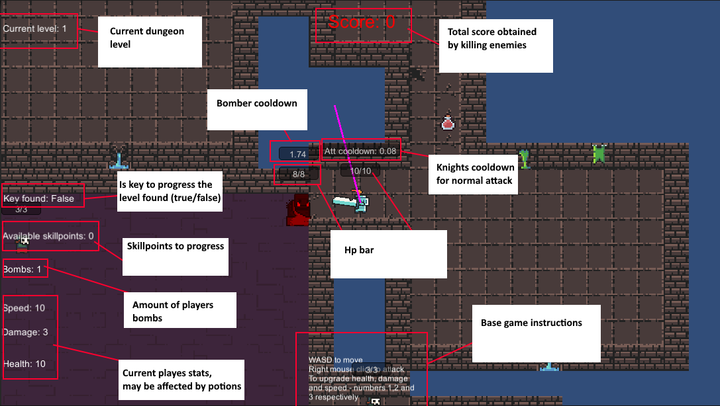

Figure 7, Whole UI

# Business definitions

Game is free and can be modified and played by anyone

# Outsourced assets

* World generation **Edgar for unity**, by OndrejNepozitek
  + <https://github.com/OndrejNepozitek/Edgar-Unity>
* Texture from **Edgar for unity**, by OndrejNepozitek
  + <https://github.com/OndrejNepozitek/Edgar-Unity>
* Explosion asset **2d Flat Explosion**, by Osama Deep
  + <https://assetstore.unity.com/packages/2d/textures-materials/2d-flat-explosion-66932>